Main – 1.5,2.5 storey
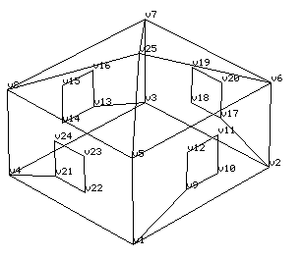
Surface Number uiSurfNum | Surface Name  SNAME[uiZoneInd][iSurfInd] |  | Number of Vertices in the Surface NVER[uiZoneInd]  [iSurfInd] | Counter-clockwise List of Vertex Points JVN[uiZoneInd][iSurfInd]  [iVertInd]
1 | Front |  | 10 | 1,2,6,5,1,9,12,11,10,9,
2 | Right | single, end unit | 10 | 2,3,7,6,2,17,20,19,18,17,
2 | Right | middle unit | 4 | 2,3,7,6,
3 | Back |  | 10 | 3,4,8,7,3,13,16,15,14,13,
4 | Left | single | 10 | 4,1,5,8,4,21,24,23,22,21,
4 | Left | middle, end unit | 4 | 4,1,5,8,
5 | to_bsm | basement, walkout, crawl space | 4 | 1,4,3,2,
5 | slab | no basement | 4 | 1,4,3,2,
6 | Front_slope | single | 3 | 5,6,25,
6 | Front_slope | end unit | 3 | 5,6,21,
6 | Front_slope | middle unit | 3 | 5,6,17,
7 | Right_slope | single | 3 | 6,7,25,
7 | Right_slope | end unit | 3 | 6,7,21,
7 | Right_slope | middle unit | 3 | 6,7,17,
8 | Back_slope | single | 3 | 7,8,25,
8 | Back_slope | end unit | 3 | 7,8,21,
8 | Back_slope | middle unit | 3 | 7,8,17,
9 | Left_slope | single | 3 | 8,5,25
9 | Left_slope | end unit | 3 | 8,5,21,
9 | Left_slope | middle unit | 3 | 8,5,17,
10 | win_Front |  | 4 | 9,10,11,12,
11 | win_Right | single, end unit | 4 | 17,18,19,20,
11 | win_Back | middle unit | 4 | 13,14,15,16,
12 | win_Back | single, end unit | 4 | 13,14,15,16,
13 | win_Left | single | 4 | 21,22,23,24,
13 | win_Left | middle, end unit | - | -

